iOS SDK Common
V1.0
Author: LIU XIAOSAN
2020/07/10

Change Log
Date | Item | Person
2020-07-10 | File created | LIU XIAO SAN
2023-11-15 | fixed function | LIU XIAO SAN

This Document is Only for Internal Use

Catalog

Change Log 1
Catalog 2
I. APP iOS SDK 4
Functions and Objectives 4
II. Integration 4
1 .Framework 4
2 . Integration 4
III. API Description 6
How to call API 6
1. Http Service Information Initialization 6
Interface Description 6
Parameters Dictionary Key Description 6
2. Http Authorized Interface 6
Interface Description 7
Parameter Description 7
3. Http Gets the Current Device Information 7
Interface Description 7
Parameter Description 7
4. Http bind the device 7
Interface Description 8
Parameter Description 8
5. Http unbind the device 8
Interface Description 8
Parameter Description 8
6. Get the Daily Report 8
Interface Description 9
Parameter Description 9
Para Dictionary Description 9
7. Get the Report Score, date format 9
Interface Description 9
Para Dictionary Description 9
Parameter Description 10
Response Object Return Parameter Description 10
Object Description 10
SLPBLEScanReturnCodes 10
Description 10
SLPDeviceTypes 11
Description 11
SLPTransforCallback 11
Description 11
Function 11
Parameter Description 11
History Data 11
Description 11
Analysis Field Description 12

I. APP iOS SDK

Functions and Objectives
Common SDK launched by Sleepace, is a software development kit for fast Internet APP development on iOS platform.

The SDK encapsulates the communication process between APP and hardware, and provides device configuration. Using this SDK, users do not need to care about complex communication protocols and the underlying implementation, only need to focus on the APP interaction and business level.

II. Integration

1 .Framework

Framework | Description
SLPCommon.framework | Common part，HTTP interface

2 . Integration
1: Add library libc++.tbd, add SLPCommon.framework into the project
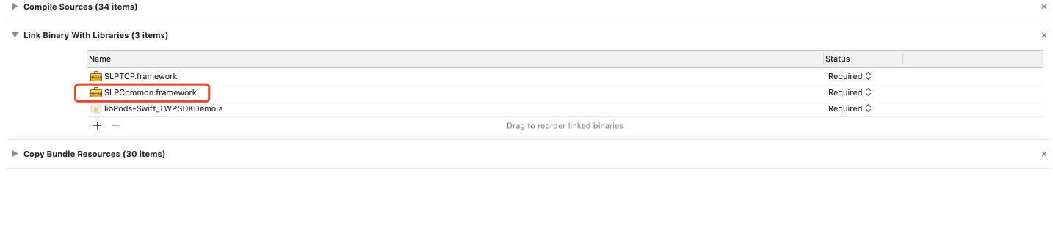
2:Since this SDK uses the third-party library AFNetworking, you need to add AFNetworking into the project. It is recommended to use the CocoaPods to manage the third-party library, or you can download and import the project yourself.

If you use the CocoaPods to manage AFNetworking, you need to add $(inherited).
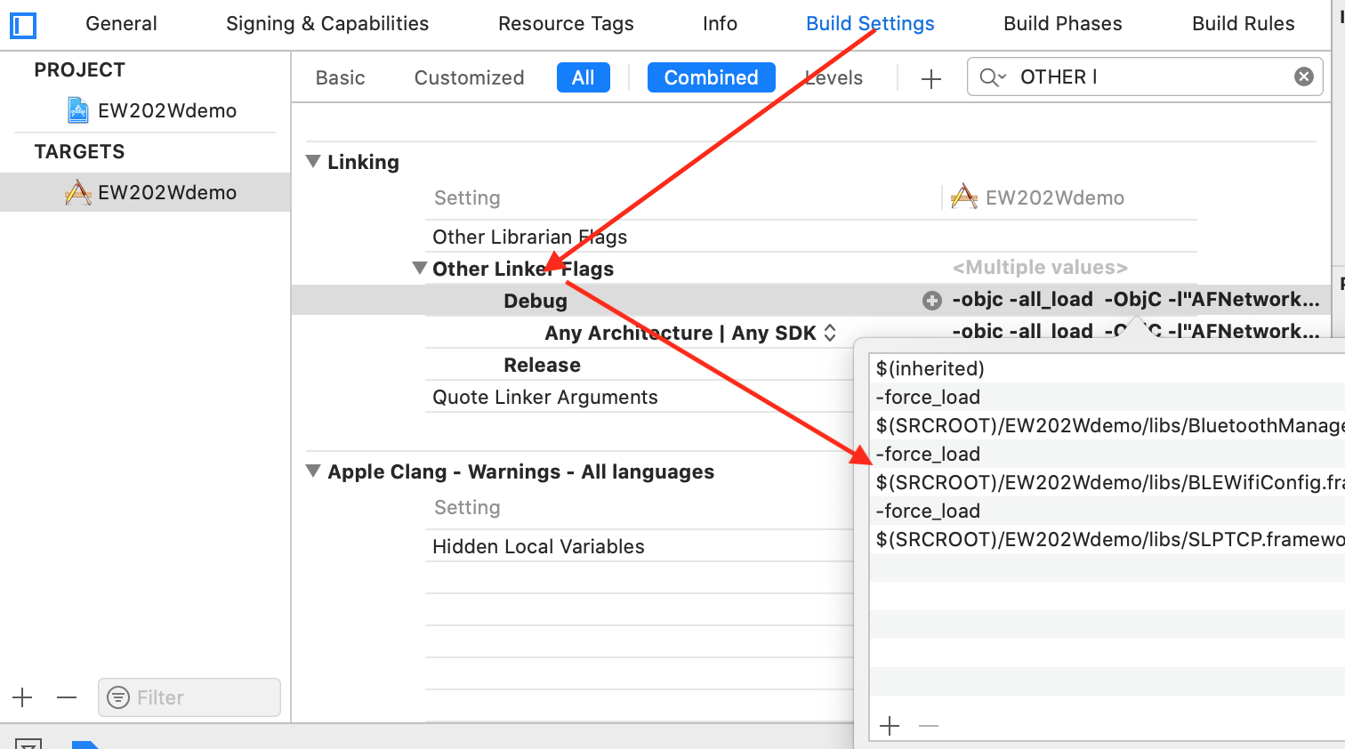

III. API Description

How to call API
You need to call the HTTP interface to get the authorized TCP address and the port number in the Common.framework before using the API

- HTTP interface
#import <SLPCommon/SLPCommon.h>
[SLPHTTPManager<方法>]

Http Service Information Initialization
- (void)initHttpServiceInfo:(NSDictionary *)parameters

Interface Description
Initiate the http address and etc.

Parameters Dictionary Key Description
Key | Type | Description
url | NSString | http address
channelID | NSString | Channel ID

Http Authorized Interface
- (void)authorize:(NSString *)token
timeout:(CGFloat)timeoutInterval
completion:(void (^)(BOOL result,id responseObject, NSString *error))completion;

Interface Description
HTTP authorized TCP address and the port number

Parameter Description
Field | Type | Description
Token | NSString | Token
timeoutInterval | CGFloat | Time-out period
completion |  | Block call back

Http Gets the Current Device Information
- (void)getBindedDeviceInformationWithUserID:(NSString *)userID
timeout:(CGFloat)timeoutInterval
completion:(void (^)(NSInteger status,id responseObject, NSString *error))completion

Interface Description
Used for getting the device information

Parameter Description
Field | Type | Description
userID | NSString | User ID
timeoutInterval | CGFloat | Time-out period (second)
completion |  | Call back interface

Http bind the device
- (void)bindDeviceWithDeviceId:(NSString *)deviceId leftRight:(int)side
userID:(NSString *)userID
timeOut:(CGFloat)timeoutInterval
completion:(void (^)(BOOL result, NSDictionary *dict,NSString *error))completion;

Interface Description
Used for binding the device

Parameter Description
Field | Type | Description
deviceId | NSString | Device ID
side | Int | left: 0 ;right: 1
userID | NSString | User ID
timeoutInterval | CGFloat | Time-out period (second)
completion |  | Call back

Http unbind the device
- (void)unBindDeviceWithDeviceId:(NSString *)deviceId leftRight:(int)side
userID:(NSString *)userID
timeOut:(CGFloat)timeoutInterval
completion:(void (^)(BOOL result,
NSString *error))completion;

Interface Description
Used for unbinding the device

Parameter Description
Field | Type | Description
deviceId | NSString | Device ID
userID | NSString | User ID
side | Int | left: 0 ;right: 1
timeoutInterval | CGFloat | Time-out period (second)
completion |  | Call back

Get the Daily Report
- (void)getDailyReport:(NSDictionary *)param timeOut:(CGFloat)timeout completion:(void (^)(BOOL result,id responseObject, NSString *error))completion;

Interface Description
Used for getting the daily report

Parameter Description
Field | Type | Description
param | NSDictionary | Input parameter dictionary
timeout | CGFloat | Time-out period (second)
completion |  | Call back

Para Dictionary Description
Key | Type | Description
startTime | Integer | Start time
num | Int | Return to record count
order | Int | Return to data order, 0 for descending order, 1 for ascending sequence
deviceType | Integer | Device type

Get the Report Score, date format
- (void)getReportScore:(NSDictionary *)param timeOut:(CGFloat)timeout completion:(void (^)(BOOL result,id responseObject, NSString *error))completion;

Interface Description
Used for getting the Report Score, date format

Para Dictionary Description
Key | Type | Description
startTime | Integer | Start time
endTime | Integer | End time
dateFormate | String | Return to the set date formate, ex. yyy-MM-dd

Parameter Description
Field | Type | Description
param | NSDictionary | Input parameter dictionary
timeout | CGFloat | Time-out period (second)
completion |  | Call back

Response Object Return Parameter Description
Field | Type | Description
date | NSString | Date
duration | Int | Real sleep duration
flaginvalid | Int | 0: Valid ; 1: body movement too weak; 2: body movement too seldom
recordCount | Int | Data length
score | Int | Score
startTime | Integer | Start time

Object Description

SLPBLEScanReturnCodes

Description
Field | Type | Description
SLPBLEScanReturnCode_Normal | 0 | Successfully scanned a Bluetooth device
SLPBLEScanReturnCode_Disable | 1 | Bluetooth is disable
SLPBLEScanReturnCode_TimeOut | 2 | Timeout

SLPDeviceTypes

Description
Field | Value | Description
SLPDeviceType_TWP2 | 0x25 | TWP2 device type

SLPTransforCallback

Description
Callback on Bluetooth or TCP requests

Function
typedef void(^SLPTransforCallback)(SLPDataTransferStatus status,id data);

Parameter Description
Field | Type | Description
status | SLPDataTransferStatus | TCP or Bluetooth request callback data, see SLPDataTransferStatus for details
data | id | The callback data is valid when the status is SLPDataTransferReturnStatus_Succeed. User must convert to a corresponding object with a different interface. For details, please see each Interface Description.

History Data

Description
Return to historical report, each point is the daily report

Analysis Field Description
Fields | Type | Description
averageBreathRate | Int | Average breath rate
averageHeartBeatRate | Int | Average heart rate
bodyMovementTimes | Int | Counts of Heat beat Pause
breathPauseAllTime | Int | Duration of apnea
breathPauseTimes | Int | Counts of apnea
breathRateFastAllTime | Int | Duration of tachypnea
breathRateSlowAllTime | Int | Duration of bradypnea
breathRateStatusAry | Array | Respiratory rate array
deepSleepAllTime | Int | Duration of deep sleep（min）
deepSleepPerc | Int | Percentage of deep sleep
duration | Int | Actual sleep duration
fallAlseepAllTime | Int | Duration of Falling asleep
fallsleepTimeStamp | Int | The time of falling asleep(time stamp)
heartBeatPauseAllTime | Int | Duration of heart beat pause
heartBeatPauseTimes | Int | Counts of heart beat pause
heartBeatRateFastAllTime | Int | Duration of tachycardia
heartBeatRateSlowAllTime | Int | Duration of bradycardia
heartRateStatusAry | Array | Array of heart rate status
inSleepAllTime | Int | Duration of mid sleep (min)
inSleepPerc | Int | Percentage of Mid sleep
leaveBedAllTime | Int | Duration of leaving bed(Unit:min)
leaveBedTimes | Int | Counts of leaving bed
leftBedStatusAry | Array | Array of leaving bed status
lightSleepAllTime | Int | Duration of light sleep
lightSleepPerc | Int | Percentage of light sleep
maxBreathRate | Int | Maximum respiratory rate
maxHeartBeatRate | Int | Maximum heart rate
md_body_move_decrease_scale | Int | Score Deduction: Score Deduction due to body movement
md_breath_high_decrease_scale | Int | Score Deduction: Score Deduction due to tachypnea
md_breath_low_decrease_scale | Int | Score Deduction: Score Deduction due to bradypnea
md_breath_stop_decrease_scale | Int | Score Deduction: Score Deduction due to apnea
md_fall_asleep_time_decrease_scale | Int | Score Deduction: Score Deduction due to long falling sleep time
md_heart_high_decrease_scale | Int | Score Deduction: Score Deduction due to tachycardia
md_heart_low_decrease_scale | Int | Score Deduction: Score Deduction due to tachycardia
md_heart_stop_decrease_scale | Int | Score Deduction: Score Deduction due to Heart beat stop
md_leave_bed_decrease_scale | Int | Score Deduction: Score Deduction due to the times of leaving bed
md_perc_deep_decrease_scale | Int | Score Deduction: Score Deduction due to lack of deep sleep
md_perc_effective_sleep_decrease_scale | Int | Score Deduction: Score Deduction due to percentage of good sleep (ratio of middle sleep/deep sleep)
md_sleep_time_decrease_scale | Int | Score Deduction due to sleeping time too short
md_sleep_time_increase_scale | Int | Score Deduction due to sleeping time too long
md_start_time_decrease_scale | Int | Score Deduction: Score Deduction due to sleeping time (too late)
md_wake_cnt_decrease_scale | Int | Score Deduction: Score Deduction due to the counts of waking up
minBreathRate | Int | Minimum of respiratory rate
minHeartBeatRate | Int | Minimum of heart rate
reportFlag | Int | 1. Long report(>3h)  2. Short report(>10m && <3h)
sleepCurveArray | Array | Sleep cycle curve
sleepCurveStatusArray | Array | Status in sleep cycle curve
sleepScore | Int | Sleep score
trunOverTimes | Int | Counts of turning over
turnOverStatusAry | Array | Array of turning over
wakeAllTime | Int | Duration of awake
wakeAndLeaveBedBeforeAllTime | Int | Duration of the time between awake and leaving bed
wakeSleepPerc | Int | Percentage of awake
wakeTimes | Int | Counts of awake
wakeupTimeStamp | Int | The time of waking up(time stamp)

Summary Fields Description
Fields | Type | Description
arithmeticVer | String | Algorithm version
deviceType | Int | Device type
firmwareVers | String | Firmware version
recordCount | Int | Report length
startTime | Integer | Start time (time stamp)
stopMode | Int | Stop mode
timezone | Integer | Time zone

Detail Fields Description
Fields | Type | Description
breathRate | Array | Array of respiratory rate value
heartRate | Array | Array of heart rate value
eHumidity | Array | Array of humidity value
eTemp | Array | Array of temperature value
status | Array | Array of status
statusValue | Array | Array of status value

